

|  |
| --- |
| **FPT UNIVERSITY** |
| Capstone Project Document |

**SMART MEDICINE DICTIONARY**

Report #6–Installation Guide

|  |
| --- |
|  |
| |  |  | | --- | --- | | **Smart Medicine Dictionary** | | | **Group Members** | |  |  | | --- | --- | | Lê Thị Xuân | 01913 | | Phạm Huy Khôi | 01888 | | Phạm Minh Tú | 01770 | | Phạm Hà Hải | 01727 | | Ngô Hà Thu | 01522 | |  |  | | | **Supervisor** | Mr. Nguyễn Văn Sang | | **Project code** | SMD |   - Hanoi, 8/2013- |

Table of Contents

1 Installation Guide 2

1.1 Introduction 2

1.2 Environment 2

1.3 Application Installation 3

1.3.1 Set up Environments: 3

1.3.2 Database creation 3

1.3.3 Deploy web application 6

1.3.4 Deploy mobile application 9

**2** **User’s Guide** 11

2.1 Purpose 11

2.2 Functional Description 11

2.3 Detail guidelines 12

2.3.1 Homepage 12

2.3.2 Quick Search Medicine 13

2.3.3 Medicine Advance Search 14

2.3.4 Pharmacy Advanced Search 14

2.3.5 Find Nearest Pharmacy ( web ) 15

2.3.6 Register 16

2.3.7 View News on web 17

2.3.8 Login 18

2.3.9 Logout 19

2.3.10 Manage Pharmacy Information 19

2.3.11 Search Registered Pharmacy ( Admin ) 19

2.3.12 Manage Medicine Information ( User ) 28

2.3.13 Search medicine on Mobile 32

2.3.14 Find the nearest pharmacy on mobile 33

2.3.15 Medical Usage Diary 33

**3** **Project Result Report** 34

3.1 Product Judging 34

3.1.1 Advantage of SMD System 34

3.1.2 Current Limitations 34

3.1.3 Expectation in Future 35

3.2 Product Summary 35

3.3 Lesson Learn 36

# Installation Guide

## Introduction

This document contains guide-lines step by step to use SMD application, and set up its own database.

## Environment

Following are the software required to start the SMD System:

- Operating System: Windows 7

- Application server: SMD application system requires an application server running on Windows 7

- Browsers : Firefox 20, Chrome 25, IE 9 or higher.

- Smartphone: Android OS version 2.3 or higher

- .NET 4.0 Framework

- Database: MySQL 5.6.9 or higher

- Apache Tomcat 6

- Tool: Eclipse Indigo SR1

## Application Installation

### Set up Environments:

- For web: If users want to use SMD system on personal computer, users need to install Chrome25 /Firefox 20/ IE9 or higher version and MySQL to create and store database.

- For mobile: Users can use SMD system on Smartphone support Android Os version 2.3 or higher.

- Tool development: Eclipse Indigo SR1

- Deployment environment for research: JDK 1.6 or JRE 1.6

- Application server for research: Tomcat 6

- Application server for real application: JBoss AS 7.1

### Database creation

Please follow these steps to create a new database for system:

**Step 1**: Preparing database.

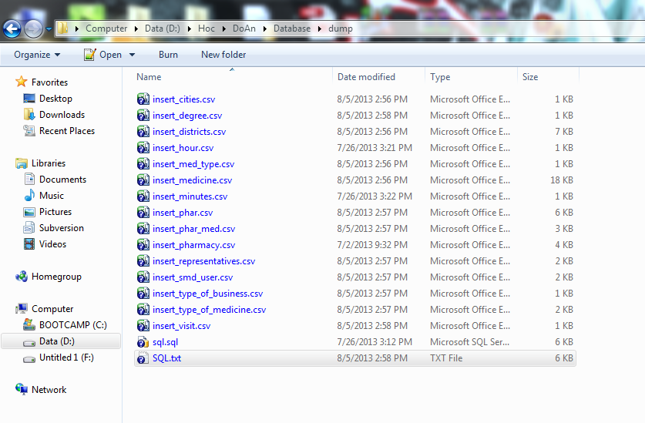

**Figure 6-1**: Create database folder

They include a .sql file and .csv file. The .sql file is database SQL scrip file and .csv file is file store data.

**Step 2**: Import database to MySQL

After we have a database server ( that installs MySQL ) as I said sooner, we open it

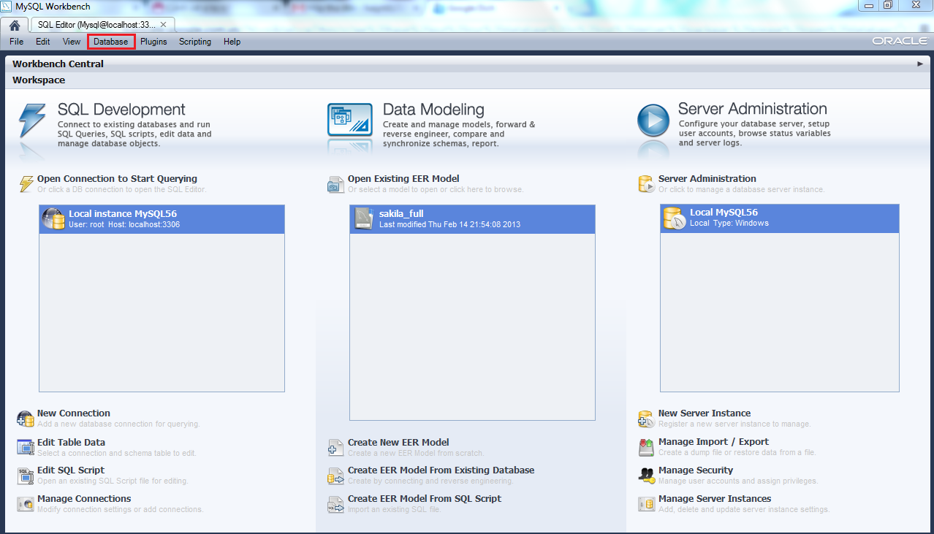

**Figure 6-2:** Open MySQL

After open MySQL, select Database menu 🡪 Query Database or press Ctrl + U 🡪 Display table to login and connect to database.

Please login to Database by the account that you have defined in the installation progress and click “OK” button.

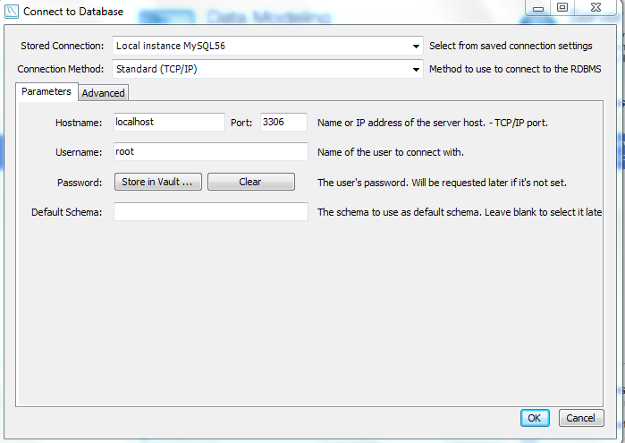

**Figure 6-3:** Login to Database

After login to MySQL server, create new schema, import file .sql and select excute

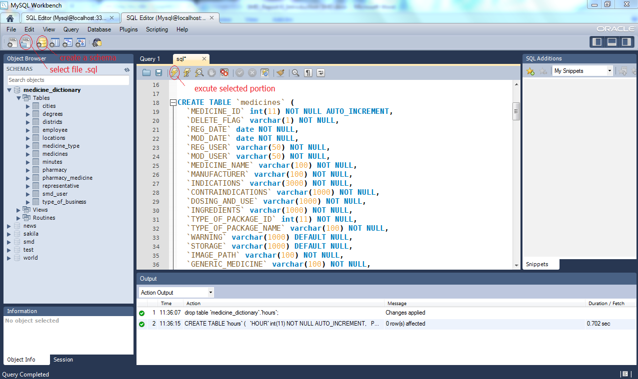

**Figure 6-4**: Execute database success

After excute .sql file, import file csv to Tables of Schema.

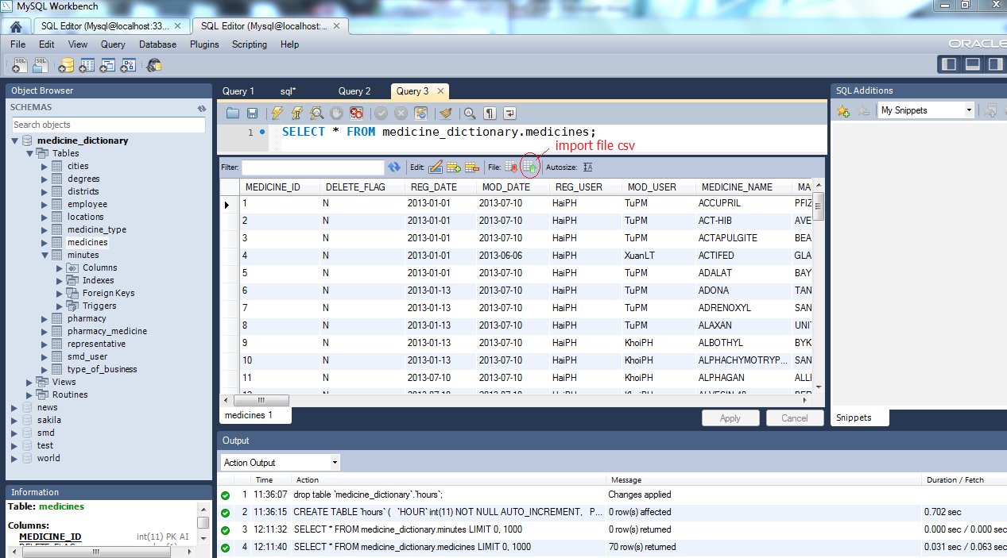

**Figure 6-5**: Import file .csv success

Through these step, you have database SMD in MySQL server.

### Deploy web application

After you have browser ( that install Firefox 20, Chrome 25, IE 9 or higher ).

Open browser and enter format link:

[http://servername:port no/MedicineDictionaryWebApp/*](http://servername:port%20no/MedicineDictionaryWebApp/*)

🡪Browser will access automatically to the home page of SMD.

#### Deploy application in Tomcat:

**Step 1**: Start Apache Tomcat

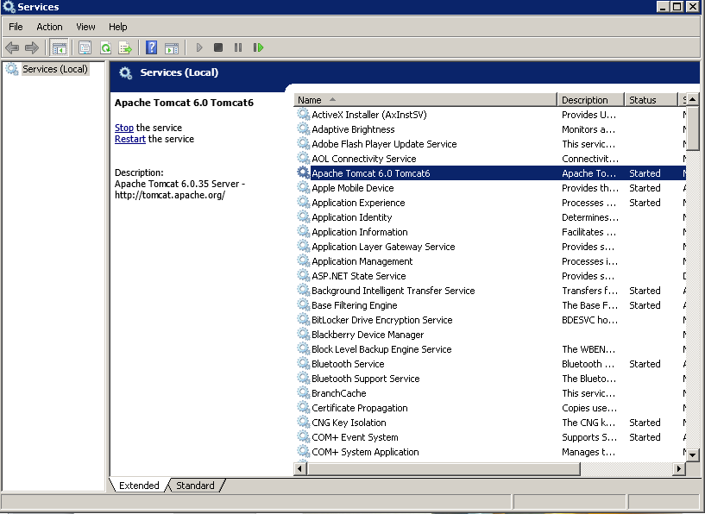

**Step 2**: Copy **MedicineDictionaryWebApp.war** to **<Apache_Home>\Tomcat 6.0\webapps**and it will deploy automatically.

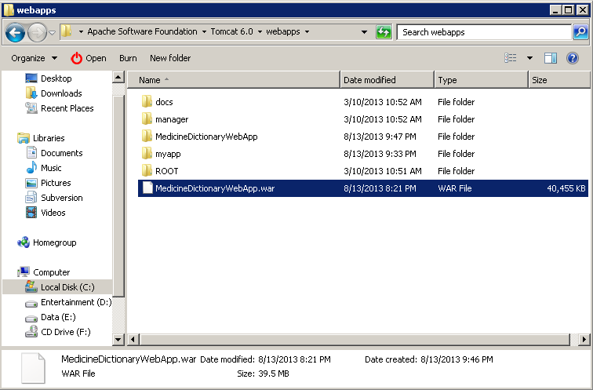

**Step 3**: Open a browser and go to link:<http://localhost:8080/MedicineDictionaryWebApp/home> and see the result

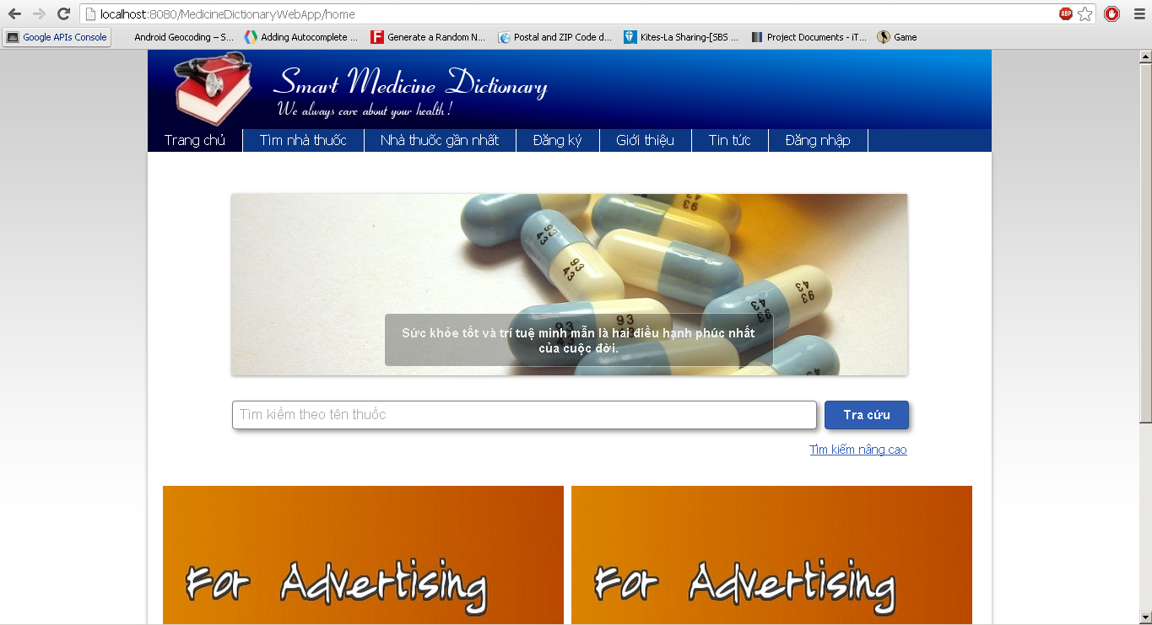

#### Deploy application in JBoss AS:

**Step 1:** Start JBoss. You can do this by starting a Standalone Server<JBOSS_HOME>\bin\standalone.bat(Windows)

You'll need to make sure you've set a JAVA_HOME system variable that points to a JDK1.6 version or later of the JDK before starting JBoss.

**Step 2**: Copy file **MedicineDictionaryWebApp.war** to **<JBOSS_HOME>\standalone\deployments**. This will "hot deploy" the Web application, which means it will automatically deploy without having to restart JBoss. If **MedicineDictionaryWebApp.war.deployed** it means that you deployed successful.

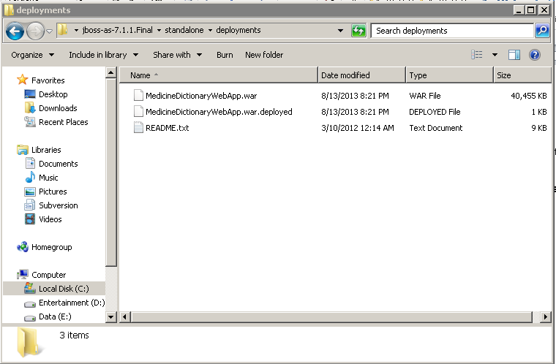

**Step 3:** Open a browser and go to link:<http://localhost:8080/MedicineDictionaryWebApp/home> and see the result



**Step 4:** Stopping the Server

The JBoss AS7 server can be stopped by pressing **Ctrl-C** on the command line.

If the server is running in a background process, the server can be stopped using the JBoss CLI:

**<JBOSS_HOME>/bin/jboss-cli.sh --connect --command=:shutdown**

### Deploy mobile application

To run this application, your mobile must be running Android OS version 2.3 or higher. First, you must download SMD .apk file to install.

There is way to download and install this file :

- In your mobile device, you access to Play Store then search SMD application and download directly to your mobile. After download, system will automatic install application on you mobile. After install successful, open application and run it.

- You also can access directly from link: ( not available )

On Local:

**Step 1**: Download AppInstaller from android market

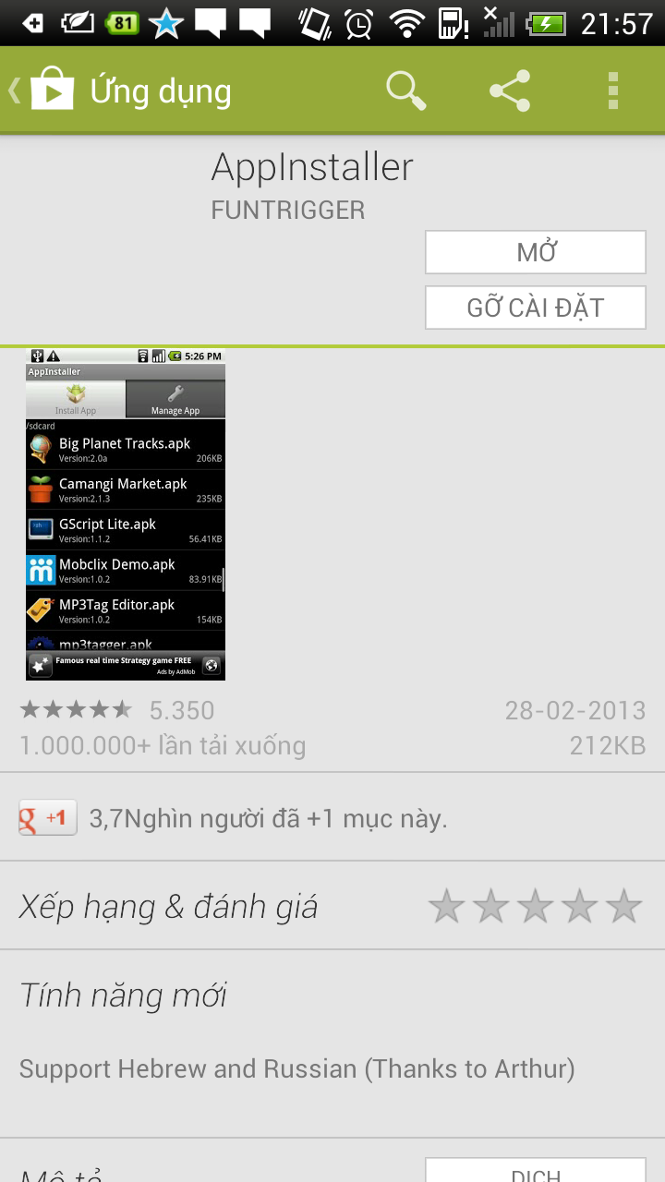

**Step 2**: Copy files SMDProject.apk to smart phone (memory card or memory in mobile)

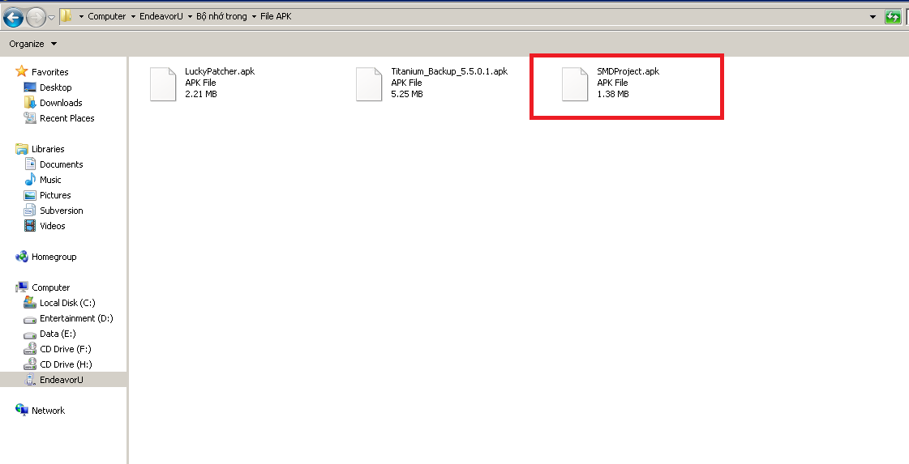

**Step 3**: Run AppInstaller to search file .APK and install to use

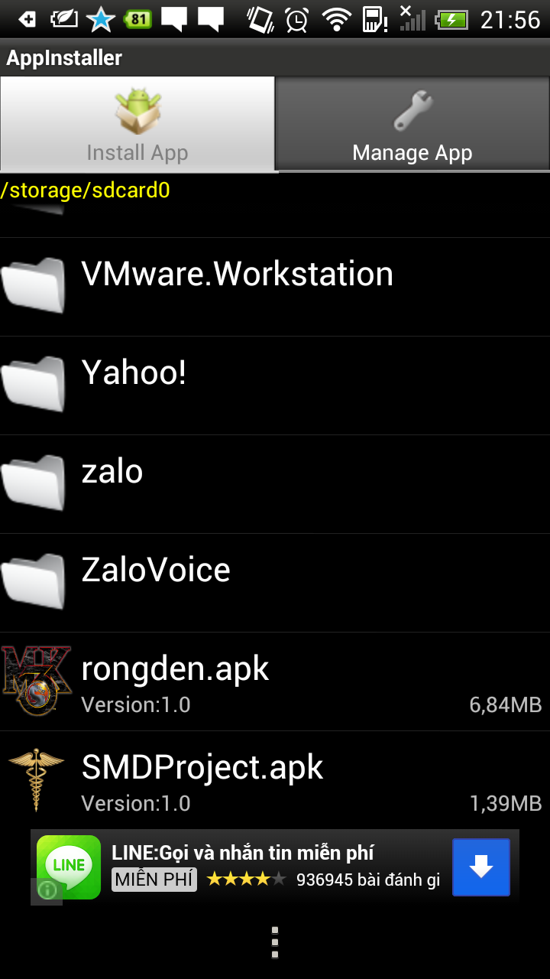

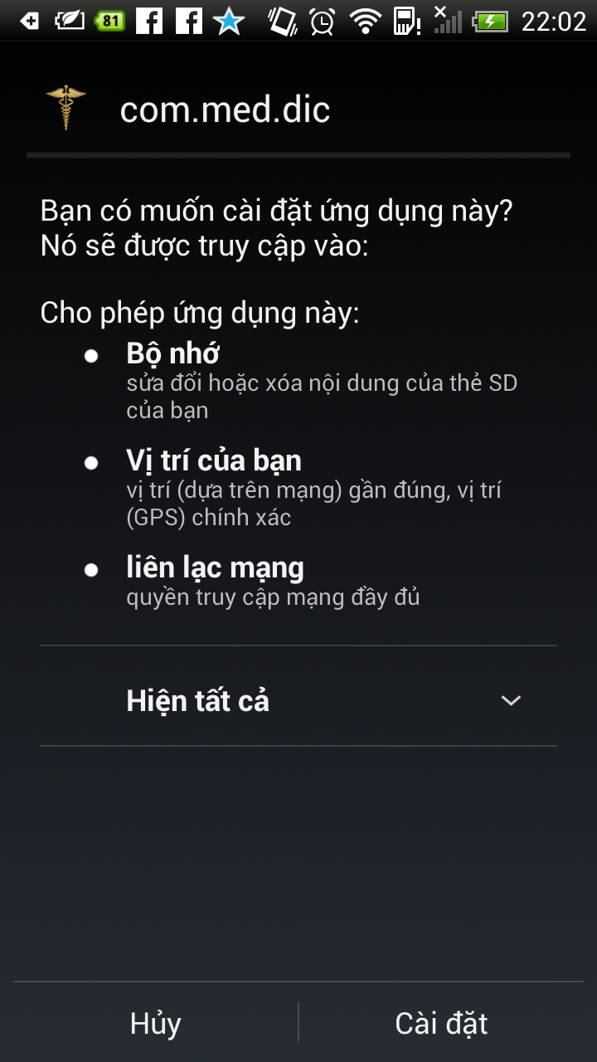

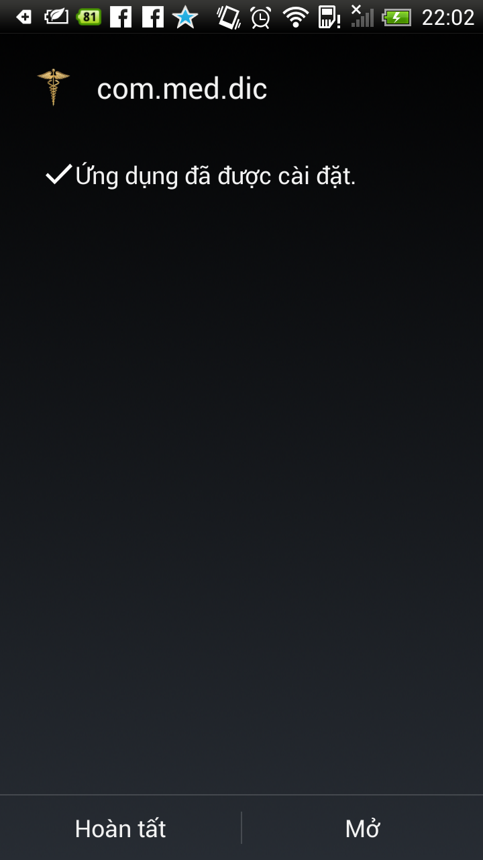

# User’s Guide

## Purpose

This user's manual has been developed to help users better understand the requirements that may apply to use this application by providing them simple step by step tutorials. This manual is intended to help make application's functions more accessible and their associated requirements more understandable to users.

## Functional Description

Before using the SMD System, you need to have an account that provides fromadministrator. After your browser loading website, the homepage will be show. For using the features of SMD application that you can access (depend on your user group), the first step that you need to do is log-into the system.

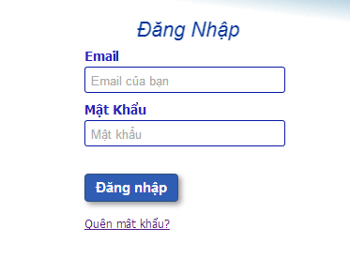

**Figure 6-6:**Login screen

## Detail guidelines

### **Homepage**

The first page which user will see is the homepage. From this page the user can go to every page they want.

**Step 1**: Open browser and enter to the address bar: localhost, IP address or name of the distant server:

Example: <http://localhost:8080/MedicineDictionaryWebApp/home>

**Step 2**: Oberver homepage.

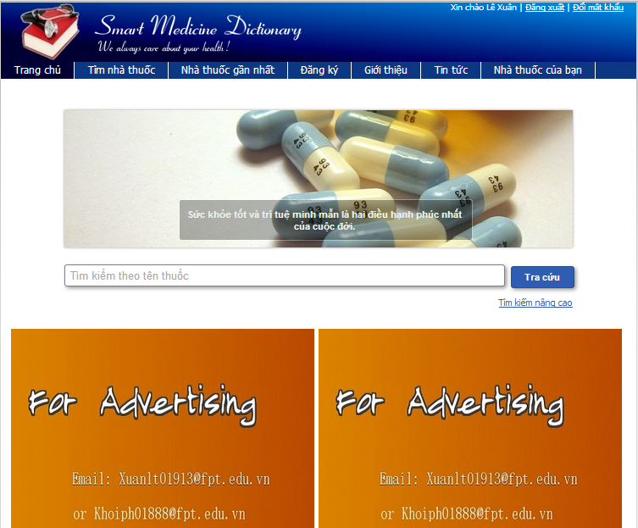

**Figure 6-7:** Homepage screen

### **Quick Search Medicine**

To use quick search function on website, the users do the steps below:

**Step 1**:Type medicine name into search box on Home page

**Step 2**: Click “Search” button 🡪Display resultlist of found medicine

**Step 3**:Click on a medicine name🡪Displays medicine detail information

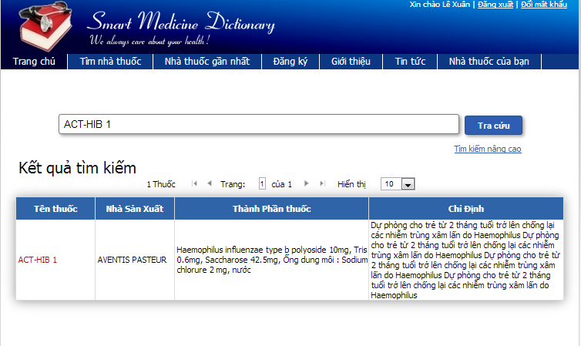

**Figure 6-8:** Quick search screen

### **Medicine Advance Search**

To use medicine advance search function on website, the users do the steps below:

**Step 1**: Click on “Medicine/ Medicine Advanced Search” hyperlink on Search Medicine screen

**Step 2**: Type the element that they want to filter result by into the right text box

**Step 3**: Click “Search” button 🡪Display resultlist of found medicine

**Step 4**: Click on medicine name on the search result🡪Displays medicine detail information

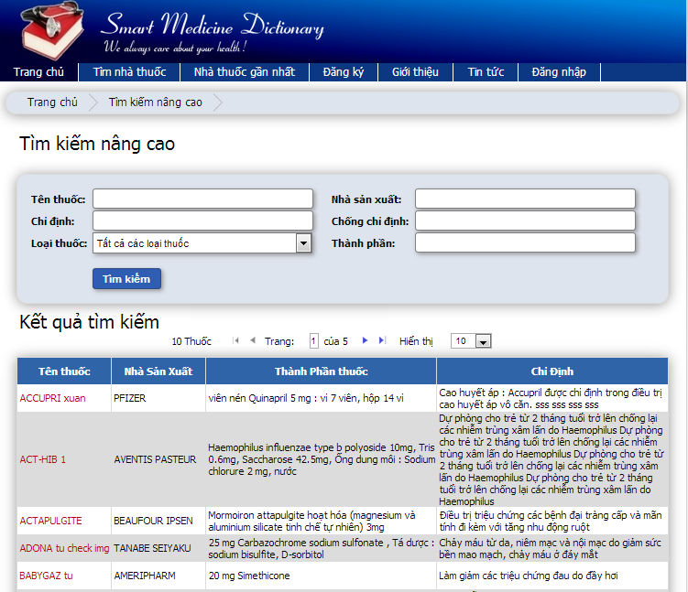

**Figure 6-9:** Medicine advanced search screen

### **Pharmacy Advanced Search**

To use pharmacy advanced search function on website, the users do the steps below:

**Step 1**: Click on “Pharmacy Advance Search” hyperlink on Search Pharmacy screen

**Step 2**: Type pharmacy name into text box then press Search button

**Step 3**: Click on pharmacy name🡪Show that pharmacy information

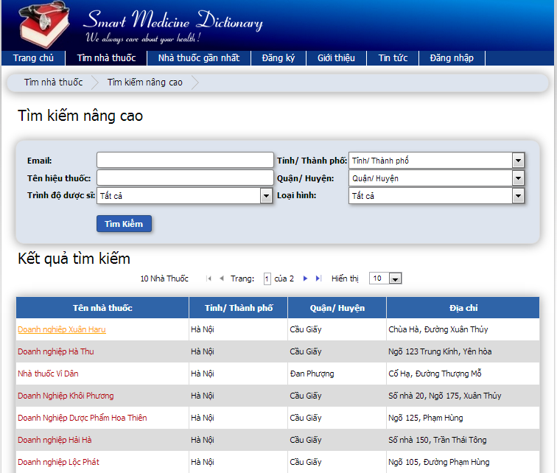

**Figure 6-10:** Pharmacy advanced search screen

### **Find Nearest Pharmacy ( web )**

To use find nearest pharmacy function on website, the users do the steps below:

**Step 1**: Click on “Find Nearest Pharmacy” tab

**Step 2**: Insert their location address into text box then press Search button

**Step 3**: Click on the nearest pharmacy icon on map🡪Show that pharmacy information and the direction to get there

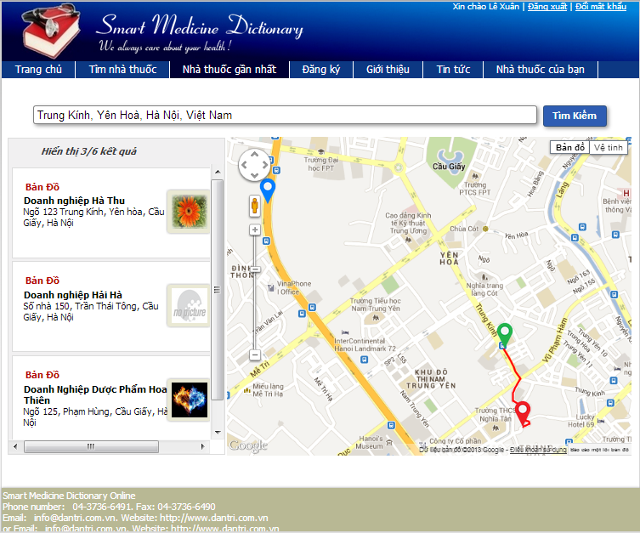

**Figure 6-9:** Find nearest pharmacy screen

### **Register**

To use register function on website, the users do the steps below:

**Step 1**: Click on “Register” tab on submenu

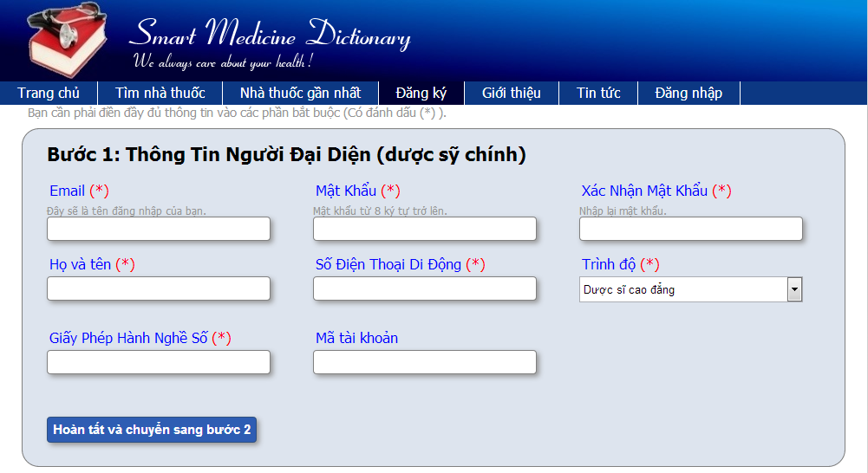

**Figure 6-9.1:** Register screen

**Step 2**: Fill all necessary and mandatory information

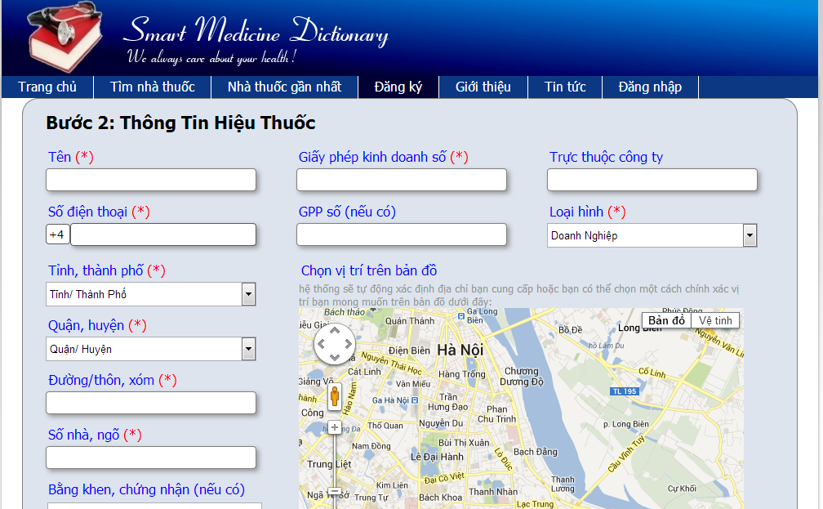

**Figure 6-9.2:** Register screen

**Step 3**: Click “Save” button

### **View News on web**

To use view News function on website, the users do the steps below:

**Step 1**: Click on News tab

**Step 2**: Clicks on one headline🡪Shows that article in detail

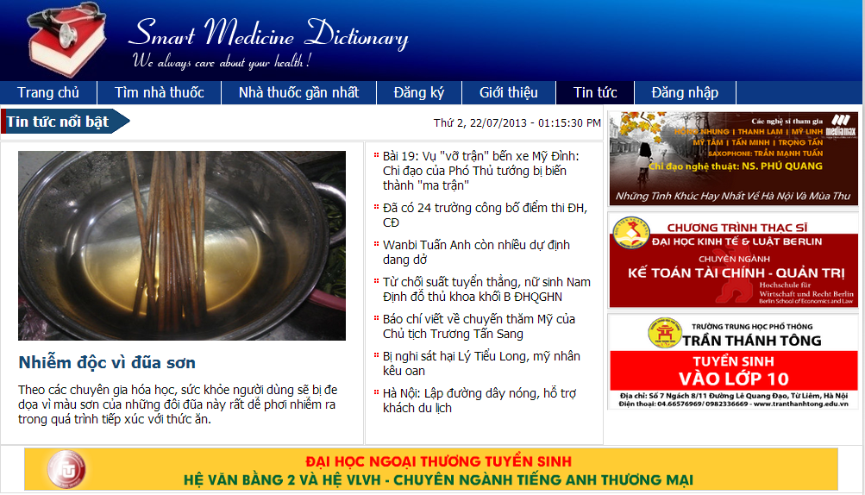

**Figure 6-10:** News screen

### **Login**

To use Login function on website, the users do the steps below:

**Step 1**: Click on “Login” hyperlink on the right top corner



**Figure 6-11.1:**Login screen

**Step 2**: Fill right User Name and Password

**Step 3**: Click “Login” button

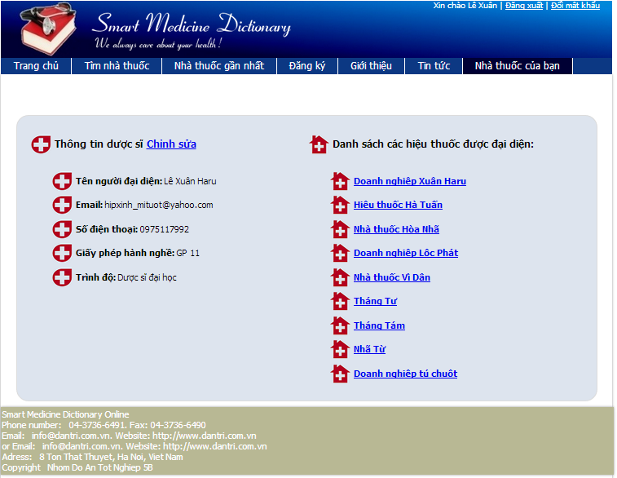

**Figure 6-11.2:** Login screen

### **Logout**

To use Logout function on website, the users do the steps below:

**Step 1**: Have logged into system

**Step 2**: Click on “Log out” link on right top corner of the page🡪 Back to login screen



**Figure 6-12:** Logout screen

### **Manage Pharmacy Information**

### **Search Registered Pharmacy ( Admin )**

To use search registered pharmacy function on website, the users do the steps below:

**Step 1**: Have logged into system as an admin

**Step 2**: Click on “Pharmacy/ Pharmacy manage” tab

**Step 3**: Fill the name of the pharmacy that they want to find into these fields then click “Search” button

**Step 4**: Click on that pharmacy name🡪Display Pharmacy information

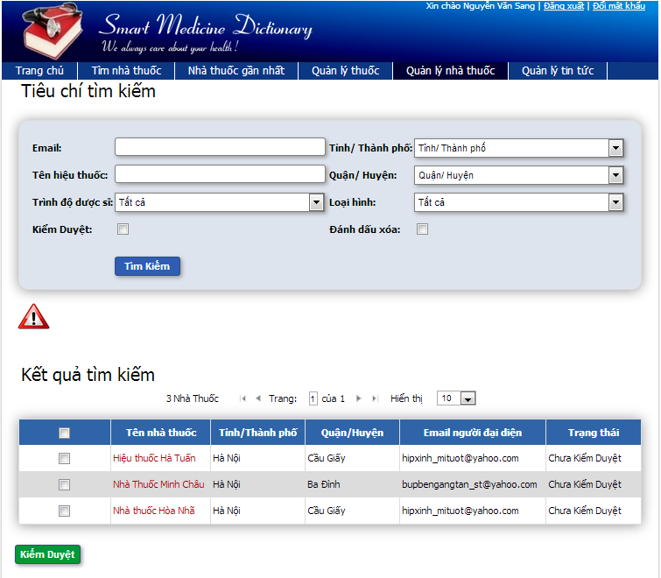

**Figure 6-13:** Search register pharmacy screen

#### **Accept Registered Pharmacy ( Admin )**

To use accept registered pharmacy function on website, the users do the steps below:

**Step 1**: Have logged into system as an admin

**Step 2**: Click on “Pharmacy/ Pharmacy management” tab

**Step 3**: Fill the name of the pharmacy that they want to find into these fields then click “Search” button

**Step 4**: Tick on check box beside the pharmacies that they want to accept

**Step 5**: Click Accept button🡪Accept these registered pharmacies to have permission to promote their information on that software

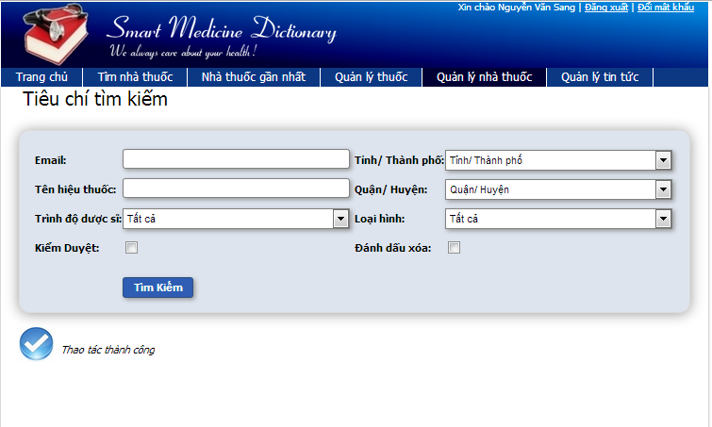

**Figure 6-14:** Accept register pharmacy screen

#### **Deny Registered Pharmacy ( Admin )**

To use deny registered pharmacy function on website, the users do the steps below:

**Step 1**: Have logged into system as an admin

**Step 2**: Click on “Pharmacy/ Pharmacy Management” tab

**Step 3**: Fill the name of the pharmacy that they want to find into these fields then click “Search” button

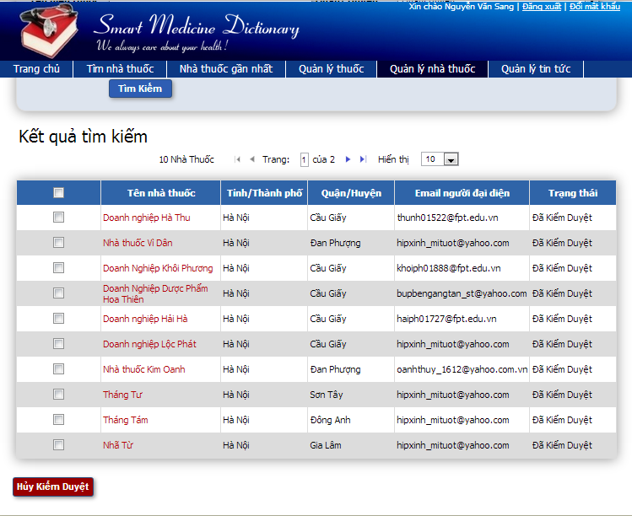

**Figure 6-15.1:** Deny register pharmacy screen

**Step 4**: Tick on check box beside the pharmacies that they want to deny or click on pharmacy you want to deny

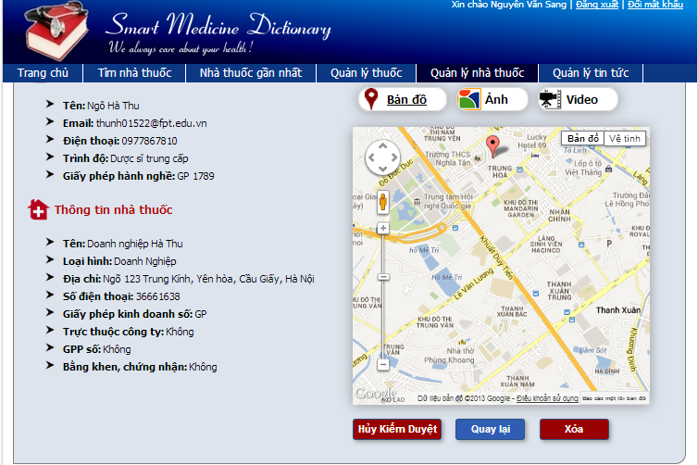

**Figure 6-15.2:** Deny register pharmacy screen

**Step 5**: Click Deny button🡪Do not approve these registered pharmacies to have permission to promote their information on that software

#### **Delete Registered Pharmacy ( Admin )**

To use delete registered pharmacy function on website, the users do the steps below:

**Step 1**: Have logged into system as an admin

**Step 2**: Click on “Pharmacy/ Pharmacy management” tab

**Step 3**: Fill the name of the pharmacy that they want to find into these fields then click “Search” button

**Step 4**: Click on pharmacy you want to delete

**Step 5**: Click Delete button🡪Delete these pharmacy from system then they do not have permission to promote their information on that software anymore

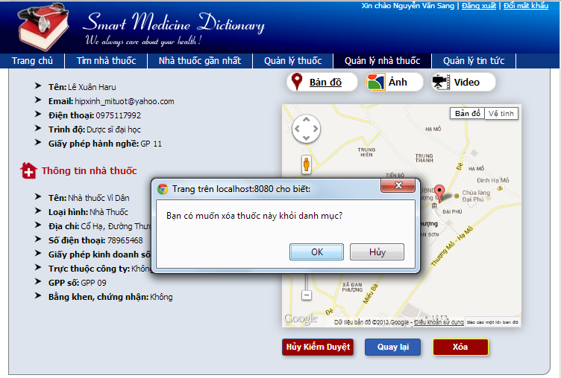

**Figure 6-16:** Delete register pharmacy screen

#### **Add New medicine ( Admin )**

To use add new medicine function on website, the users do the steps below:

**Step 1**: Have logged into system as an admin

**Step 2**: Click on “Medicine/ Add new” tab

**Step 3**: Fill medicine information into all necessary or mandatory fields

**Step 4**: Click “Save” button🡪The system validates the input data and then save new medicine data into database

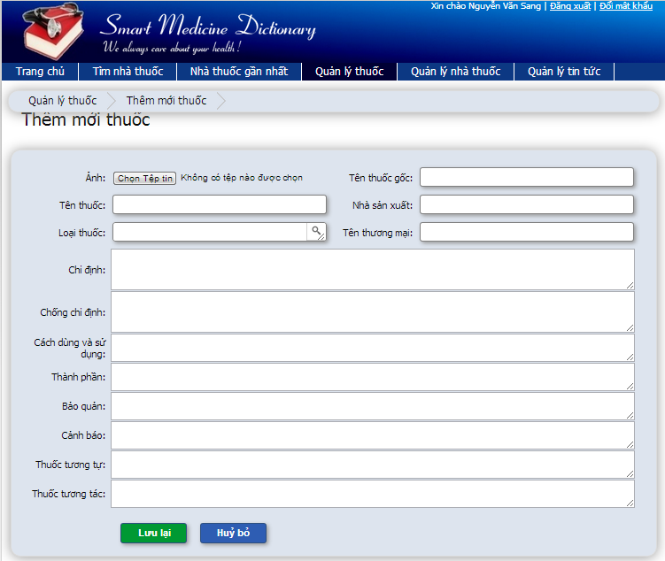

**Figure 6-17:** Add new medicine screen

#### **Copy New medicine ( Admin )**

To use copy new medicine function on website, the users do the steps below:

**Step 1**: Have logged into system as an admin

**Step 2**: Click on “Medicine/ Medicine Advanced Search ” then search for the medicine that they want to copy

**Step 3**: Click on “Copy New” button beside that medicine row

**Step 4**: Edit medicine information

**Step 5**: Click “Save” button🡪The system validates the input data and then save data into database

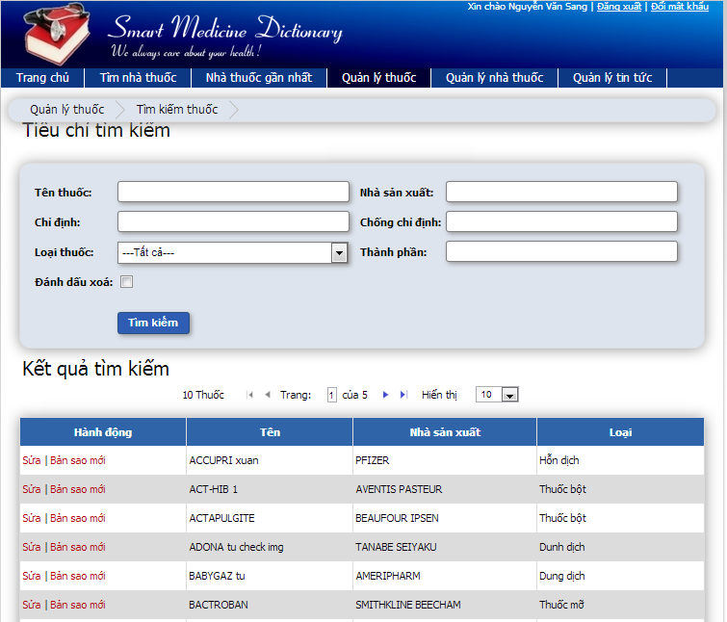

**Figure 6-18:** Copy new medicine screen

#### **Edit medicine ( Admin )**

To use edit medicine function on website, the users do the steps below:

**Step 1**:Have logged into system as an admin

**Step 2**: Click on “Medicine/ Medicine Advanced Search ” then search for the medicine that they want to edit

**Step 3**: Click on Edit button beside that medicine row

**Step 4**: Edit medicine information

**Step 5**: Click “Save” button🡪The system validates the input data and then save edited data into database

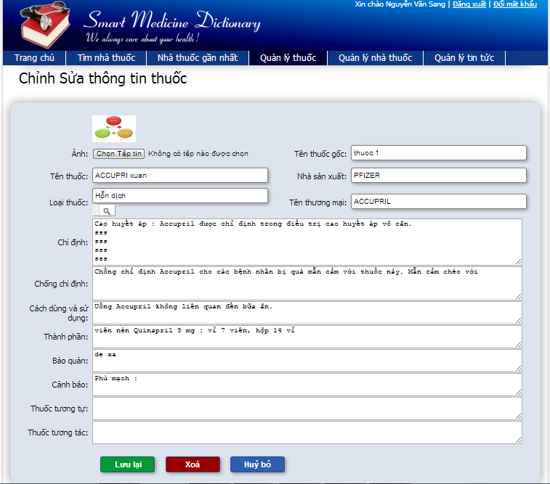

**Figure 6-19:** Edit medicine screen

#### **Delete medicine ( Admin )**

To use delete medicine function on website, the users do the steps below:

**Step 1**:Have logged into system as an admin

**Step 2**: Click on “Medicine/ Medicine Advanced Search ” then search for the medicine that they want to edit

**Step 3**: Click on “Delete” button beside that medicine row

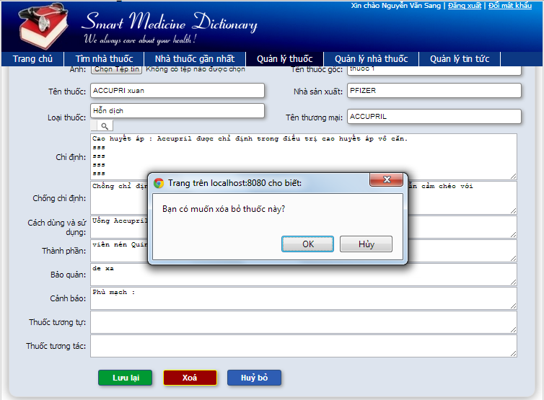

**Figure 6-20.1:** Delete medicine screen

**Step 4**: Click “Yes” button on popup🡪Closes the popup then remove that medicine name from medicine list

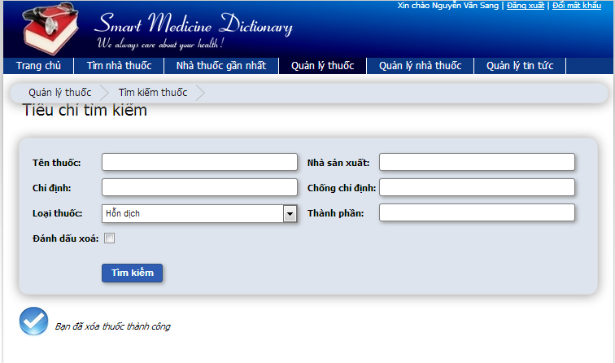

**Figure 6-20.2:** Delete medicine screen

#### **Restore medicine ( Admin )**

To use restore medicine function on website, the users do the steps below:

**Step 1**: Have logged into system as an admin

**Step 2**: Click on “Medicine/ Medicine Advanced Search ” tab

**Step 3**: Tick on Delete flag then search for the medicine that they want to edit

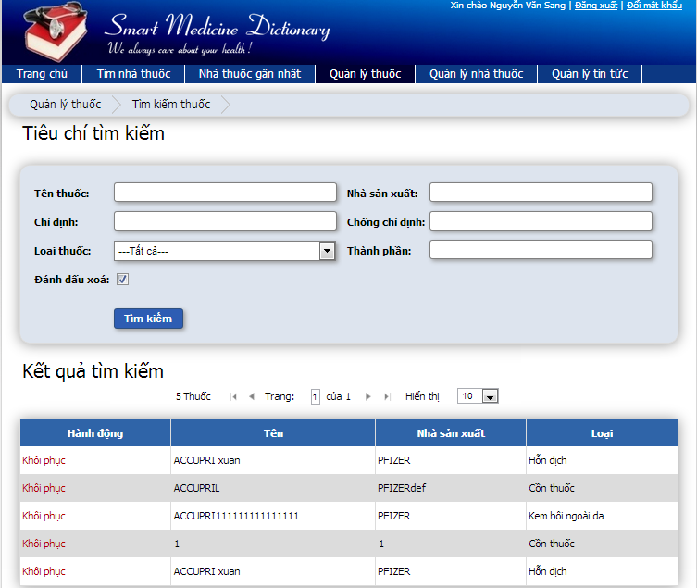

**Figure 6-21.1:** Restore medicine screen

**Step 4**: Click on “Restore” button beside that medicine row

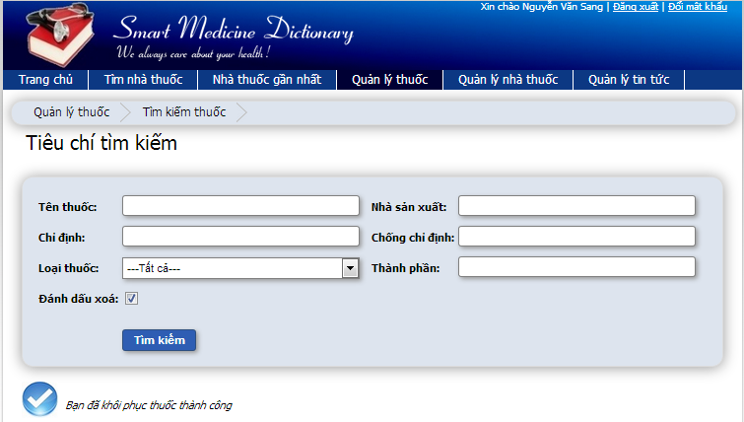

**Figure 6-21.2:** Restore medicine screen

### **Manage Medicine Information ( User )**

#### **Change Information ( User )**

To use change information function on website, the users do the steps below:

**Step 1**: Have logged into system as an user

**Step 2**: Click on pharmacy user representative

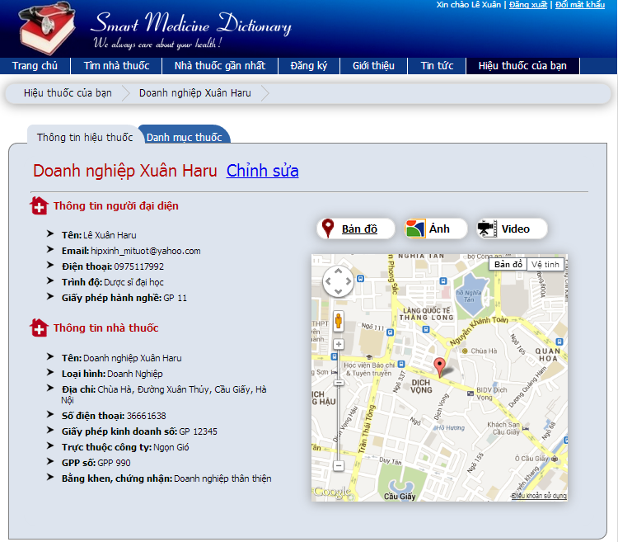

**Figure 6-22.1:** Change information screen

**Step 3**: Click on “Change information” button

**Step 4**: Type new information into text fields (validate)

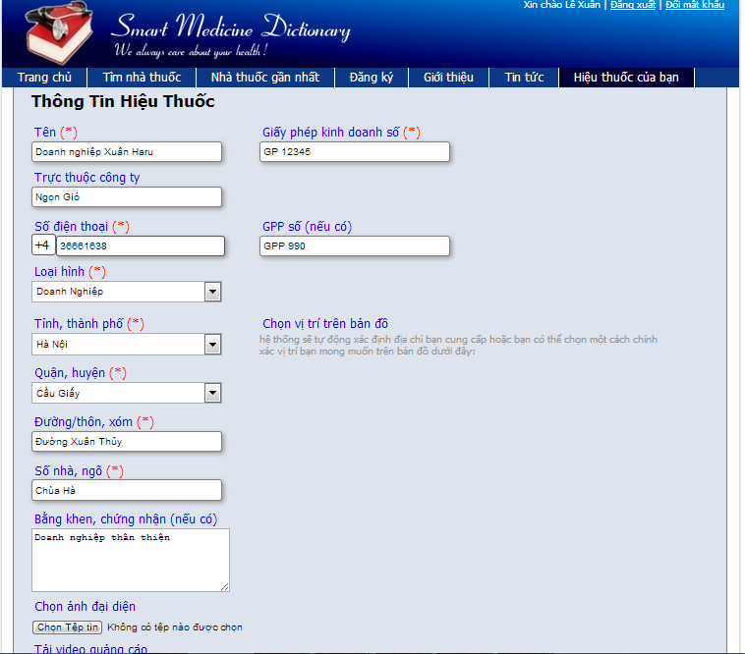

**Figure 6-22.2:** Change information screen

**Step 5**: Click on “Save” button🡪The system validates the input data and then save new information into database

#### **Change password ( User )**

To use change passwordfunction on website, the users do the steps below:

**Step1**: Have logged into system as an user

**Step 2**: Click on “Change password” link on the right top corner of the page



**Figure 6-23.1:** Change password screen

**Step 3**: Insert current password then insert new password that is validate

**Step 4**: Click “Change password” button🡪Display successful page with message to inform user that new password can be used after being confirm by admin



**Figure 6-23.2:** Change password screen

#### **Add new medicine into pharmacy’s sell list ( User )**

To use add new medicine into pharmacy’s sell listfunction on website, the users do the steps below:

**Step 1**: Have logged into system as an user

**Step 2**: Click on Manage tab on submenu

**Step 3**: Click on one pharmacy name

**Step 4**: Click on “Selling list” tab

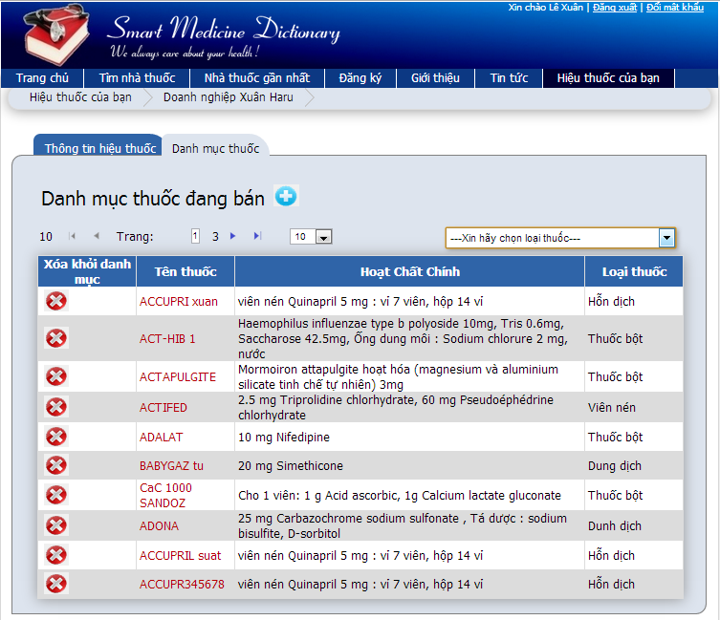

**Figure 6-24.1:** Add new medicine to sell list screen

**Step 5**: Click on “Add new” button

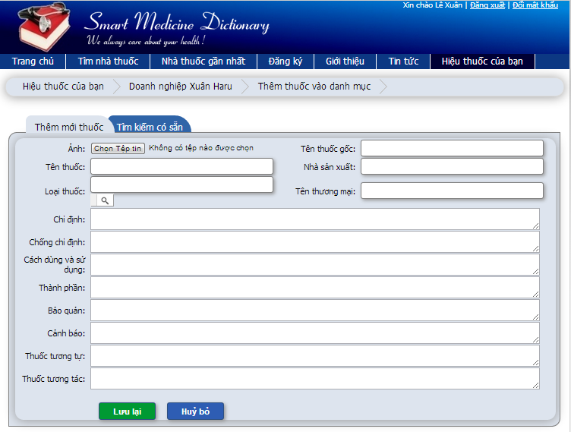

**Figure 6-24.2:** Add new medicine to sell list screen

**Step 6**: Fill medicine information into all necessary or mandatory fields

**Step 7**: Click Save button

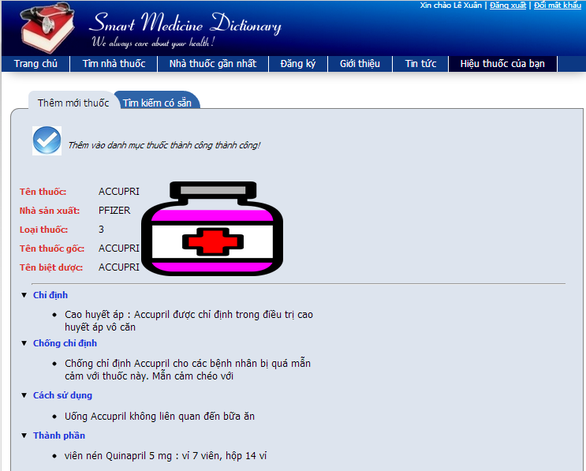

**Figure 6-24.3:** Add new medicine to sell list screen

### **Search medicine on Mobile**

To use Search medicine function on mobile, the users do the steps below:

**Step 1**:Click on that application icon on mobile

**Step 2**: Type medicine name into search box on home page

**Step 3**: Click “Search” button

**Step 4**: Click on a medicine name🡪Displays medicine detail information

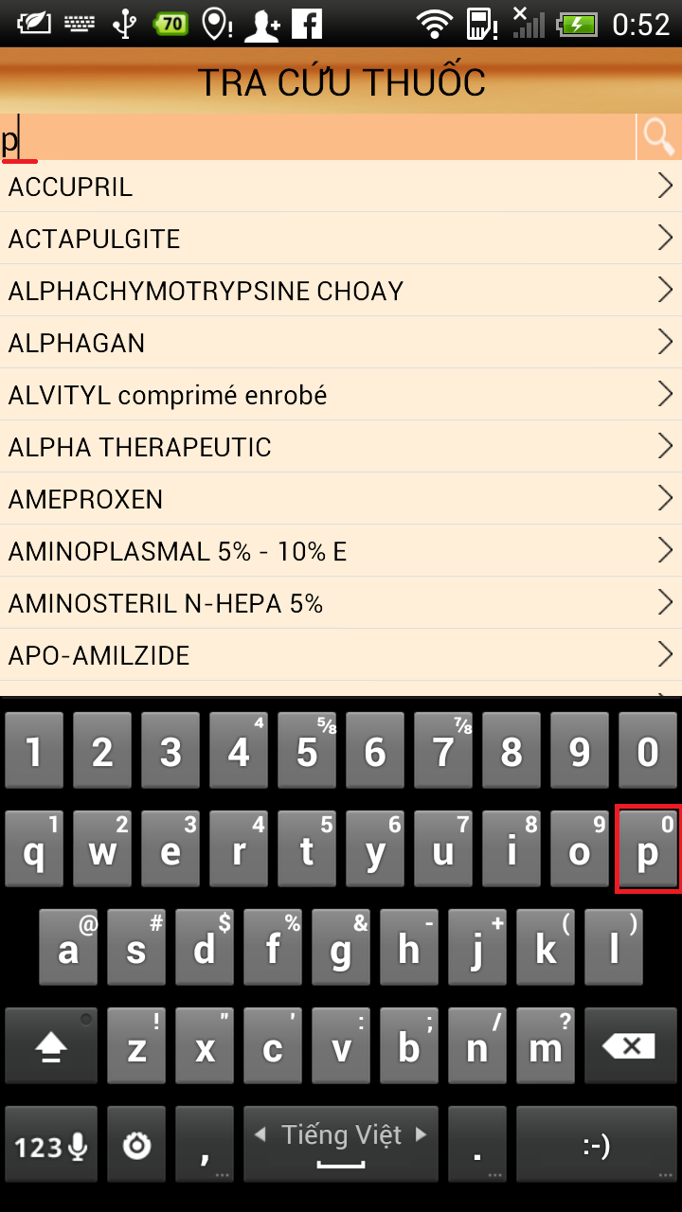

**Figure 6-25:** Search medicine on mobile screen

### **Find the nearest pharmacy on mobile**

To use findthe nearest pharmacy function on mobile, the users do the steps below:

**Step 1**: Click on “Nhà Thuốc” submenu on the Home screen

**Step 2**: Typing their location on “Location” text box

**Step 3**: Click “Search” button 🡪Show your current location and path to the nearest pharmacy location

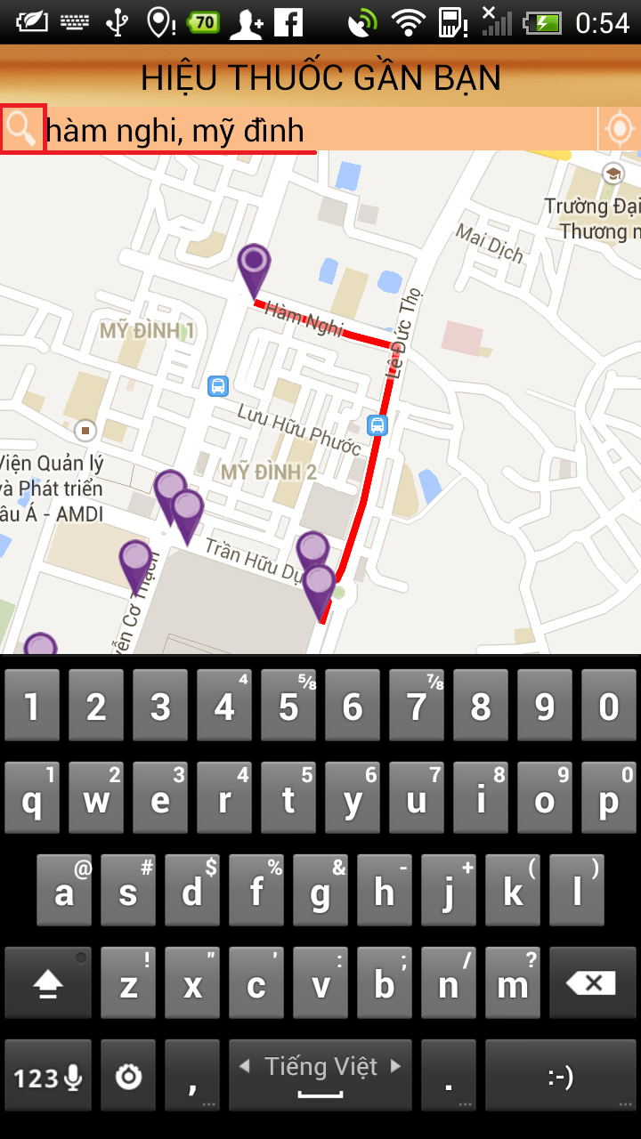

**Figure 6-26:** Find nearest pharmacy on mobile screen

### **Medical Usage Diary**

To use medical usage diary function on mobile, the users do the steps below:

**Step 1**: Click on “Đơn Thuốc” submenu on Home screen

**Step 2**: Click on “Thêm mới” button

**Step 3**: Fill all fields

**Step 4**: Click “Lưu lại” button

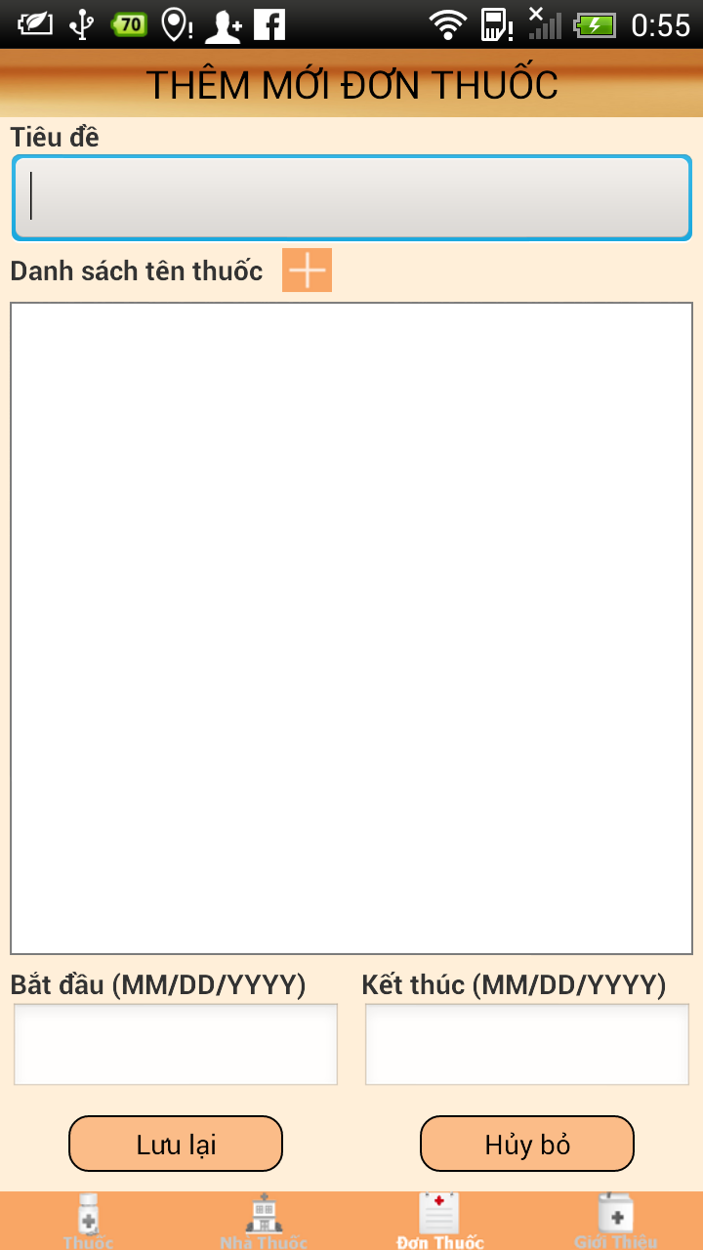

**Figure 6-27:** Medical usage diary on mobile screen

# Project Result Report

## Product Judging

### **Advantage of SMD System**

The idea of the SMD project is to develop a new product that inherits the advantages and improve issues and learns from other products. And the new product would have the opportunity to add a lot of enhancements.

As the goals that we have set before started the project, the SMD system has been developed in a right direction. And what it provides to users is in the list below:

* Find information about the medicines easily, quickly and accurately.
* Find the nearest pharmacy and path to the nearest pharmacy location.
* Promote the image of the pharmacy, enhanced reputation and brand with users
* Manage information about medicines easily and accurately.
* Read and update News about medical
* Easy to use and can be installed and use on Smartphone ( android Os )
* Diary function on mobile helps remind users use medicine on time.

### **Current Limitations**

* GUI, Testcase and Reportstructure is still in upgrading
* Not have account for put up SMD application to Play Store

### **Expectation in Future**

* First, continuously develop this module, improve the way interact with user (through GUI, report…).
* Second, develop and add function diagnose the diseases online. User can enter symptoms and answer some questions,system will diagnose and give treatments with high accuracy.
* Put up SMD application to Play Store, easy to download and install on mobile.

## Product Summary

|  |  |  |  |
| --- | --- | --- | --- |
| **Project Title** | | Smart Medicine Dictionary | |
| **Project Supervisor** | | Nguyễn Văn Sang | |
| Committers (5) | | | |
| 1 | Project Manager | Lê Thị Xuân | [XuanLT01913@fpt.edu.vn](mailto:XuanLT01913@fpt.edu.vn) |
| 2 | Configuration Manager | Phạm Huy Khôi | [KhoiPH01888@fpt.edu.vn](mailto:KhoiPH01888@fpt.edu.vn) |
| 3 | Designer | Phạm Minh Tú | [TuPM01770@fpt.edu.vn](mailto:TuPM01770@fpt.edu.vn) |
| 4 | QA + Tester | Phạm Hà Hải | [HaiPH01727@fpt.edu.vn](mailto:HaiPH01727@fpt.edu.vn) |
| 5 | QA + Tester | Ngô Hà Thu | [ThuNH01522@fpt.edu.vn](mailto:ThuNH01522@fpt.edu.vn) |
| Main objective | | Develop medicine dictionary online, help user lookup information about medicines easily, quickly and accurately. Find the nearest pharmacy and path to the nearest pharmacy location. Diary function on mobile helps remind users use medicine on time | |
| Purpose | | Provide a SMD online on website and a SMD application on mobile. | |
| Source Repository | | [https://fu-se509-mdp.googlecode.com/svn/trunk/Source](https://fu-se509-mdp.googlecode.com/svn/trunk/Source%20) | |
|  | | **Plan** | **Actual** |
| Releases Date | | 15/08/2013 | 15/08/2013 |
| Releases version | | 1.0 | 1.0 |
| Days | | 89 days | 89 days |
| Test cases | |  |  |
| Defects | |  |  |
| Document pages | | ~ 200 (include appendix) | > 200 (include appendix) |
| Lines of code | | ~30000 | ~ 50000 |

## Lesson Learn

* Have experience and deeply understand about SMD System
* Understand about the general process or work flow of test processes.
* Improve skill
  + Technical: Struts 2, Spring 3, Hibernate 3, Javascript, css, Json, Android, Webservice.
  + Database: MySQL
  + Softskill: brainstorm, teamwork, research and self-study, plan management, time management and project management.
* Risk and issues management
  + Technique :
    - No members have experiences work with some framework as Struts 2, Spring 3, Hibernate 3, and Android. So before start this project, we divided the project into two separate arrays are web and mobile and assign some members to take responsibility for researching and training the others.
    - Not understanding about general / detail technical: researching internet, asking for supporting from community.
  + Human resources:
    - Some members are lazy for a while so we define detail schedules, and often reminding each other.
    - Laptop of a member was stolen so need to buy new laptop and setup environment to continues task
    - One member had an accident and cannot join the project for some days so the others (who have free time) replaced him for these days.
    - Members were lack of project information, so we use many method to prevent this issue, we use the general SVN from sourceforce.com; everyone can keep up with the project.

🡪 Meeting for brainstorming

🡪 Scheduling and reporting

* + Over time, because of:
    - Risk: technique, resources.
    - Not pay attention at the beginning, lazy